Project Management Plan

**Document History**

|  |  |  |  |  |  |  |
| --- | --- | --- | --- | --- | --- | --- |
| **Document Name** | **Version** | **Status** | **Date** | **Viewable** | **Reviewer** | **Responsible** |
| iWish-PMP_V.0.1.docx | **Add**   * Introduction * Infrastructure * Management Procedure * Quality Plan * Estimated Duration of Tasks * Estimated Effort and Cost * Version Control Strategy | Draft | 20-05-2015 | VC, SK, KS | VC, SK | VC, SK |
| iWish-PMP_V.1.docx | **Edit**   * Introduction * Infrastructure * Management Procedure * Quality Plan * Estimated Duration of Tasks * Estimated Effort and Cost * Version Control Strategy | Release | 22-07-2015 | VC, SK, KS | VC, SK | VC, SK |
| iWish-PMP_V.1.5.docx | **Edit**   * Introduction * Infrastructure * Management Procedure * Quality Plan * Estimated Duration of Tasks * Estimated Effort and Cost * Version Control Strategy | Release | 23-08-2015 | VC, SK, KS | VC, SK | VC, SK |

**\*VC = Visava Chumnuam**

**\*SK = Saksorn Khongsirirat**

**\*KS = Kittitouch Suteeca**

**Table of Contents**

1. Introduction 5

1.1 Project Overview 5

1.1.1 Purpose 6

1.1.2 Scope 6

1.2 Work Product to be developed 9

1.2.1 Deliverables 9

1.2.2 Non Deliverables 10

02. Infrastructure 11

2.1 Hardware/Software Acquisition Plans 11

2.2 Project Specific system 11

3. Management Procedures 12

3.1 Project Team Structure 12

3.2 Monitoring and Controlling Mechanisms 12

3.2.1 Software Development Model 12

3.2.2 Status Reporting 14

3.3 Change Management 15

4. Quality Planning [V&V] 16

4.1 Reviews/Responsibility 16

4.2 Testing 16

4.3 Software Development Standard 17

5. Estimated Duration of Tasks 21

6. Estimated Effort and Cost 26

7. Version Control Strategy 26

7.1 Naming Conversion 26

7.2 Project Repository 26

7.3 Configuration Item Table 26

8 . Reference…………………………………………………………………………………………………..…....28

# **Introduction**

Currently, shopping to buy some products is the thing that all people have to do. Sometimes they want to buy a lot of products. But when they bought the products and took the products to their home. They find they forgot to buy some product. It is a big problem if the distance from their home to the supermarket is far. If those products are needed, they have to go to the supermarket again to buy it. They will waste the time and money to get back to the supermarket. Or sometimes, they want to know how much of the total price of the products to manage their budget. It will better if they have some tool that they can manage their shopping.

In this project plan, it will introduce how to manage the iWish project and which quality standard will be used. For this document is about project planning, which consists of overall of the project, deliverable products, project requirement, develop planning and quality plan.

## Project Overview

The overview of the project will be two parts. The first is a supermarket site. The admin will provide NFC tag and barcode that linked to a database that managed by the admin. When the customers wants to buy a lot of products. The customer may forget to buy something. But if the customers use this application, they will not forget to buy the products. Because the customers can set wish list what are the products that want to buy. And can set the expected price. When they go to shopping, the customers can use this application to get the information such as name, net weight and price of each product. By using NFC or barcode scanner features. The application will connect to the database and bring the information of products to the customers. Then the customers can use the application to compare or calculate the total price of the product.

* + 1. **Purpose**

The purpose of iWish application is providing convenience and save the time for customers to make no forget to buy products. The customers can go shopping and compare prices each product brand in the same category.

* + 1. **Scope**

Using Android studio to develop the application.

* Focus on only one supermarket.
* Provide management system products in database.
* Provide Android application for managing wish list.
* Convenient features for Android application site.
  + 1. **Acronyms and Definition**

**Acronyms**

ADA Activity Diagram Android

ADW Activity Diagram Web Application

APK Android Package Kit

SD Sequence Diagram

SK Saksorn Khongsirirat

SRS System Requirement Specification

NFC Near field communication

UCA Use case Diagram Android

UCW Use case Diagram Website

URSA User Requirement Specification Android

URSW User Requirement Specification Website

VC Visava Chumnuam

**Definition**

**IEEE**

Institute for Electrical and Electronics Engineers. Biggest global interest group for engineers of different branches and computer scientists. [IEEE90]

**Integration Testing**

The progressive linking and testing of software components in order to ensure their proper functioning in the whole system. [IEEE90]

**Milestone**

A significant event in the project, usually completion of the main deliverable. [IEEE90]

**Plan**

A documented series of tasks requires meeting an objective, typically including the associated schedule, budget, resources, organizational description and work breakdown structure. [IEEE90]

**Project management** [IEEE90]

The application of knowledge, skills, tools, and techniques to project activities in order to meet or exceed stakeholder needs and expectations from a project.

**Project Plan** [IEEE90]

A formal, approved document used to guide both project execution and project control. The primary uses of the project plan are to document planning assumptions and the decision, to facilitate communication among stakeholders, and to document approved scope, cost, and schedule baseline.

**Risk** [IEEE90]

An uncertain event or condition that, if it occurs, has a positive or negative effect on a project’s objectives. It is a function of the probability of occurrence of a given threat’s occurrence.

**Risk management** [IEEE90]

The systematic application of management policies, procedures and practices to the tasks of identifying, analyzing, evaluating, treating and monitoring risk.

**System testing** [IEEE90]

Testing conducted on a complete and integrated system for evaluate the system’s compliance with its specified requirements

**Traceability** [IEEE90]

The ability to trace the history, application or location of an item or activity, or work products or activities, by means of recorded identification. The establishment and maintenance of relationships between such items. Horizontal traceability describes the relationship between work products of the same type (e.g., Customer requirements). Vertical traceability describes the relationship between work products, which build or derived from each other (e.g., from customer requirements to qualification test cases). Bidirectional traceability allows to directly following relationships in both directions.

**Validation** [IEEE90]

Confirmation by examination and provision of objective evidence that the particular requirements for a specific intended use are fulfilled (“doing the right thing”). Part of quality control.

**Verification** [IEEE90]

Confirmation at the end of the process by examination and provision of objective evidence that specified requirements to the process have been fulfilled (“doing things right”). Part of quality control.

**UML Unified Modeling Languages** [IEEE90]

Standardized notation for modeling design descriptions, architectures or scenarios. Not depending on a specific method. Issued and maintained by the object Management Group.

**Unit test** [IEEE90]

A test of individual programs or modules in order to remove a design or programming errors.

## 1.2 Work Product to be developed

### Deliverables

|  |  |  |  |  |
| --- | --- | --- | --- | --- |
| **No.** | **Deliverables/Release** | **Media** | **No. Of Copies** | **Date** |
| 1. | **The Proposal report**   * Project Proposal Version 1.0 | Hard Copy | 3 | 18/06/2015 |
| 2. | **The Progress report I**   * Project Management Plan version 1.0 * Software Requirement Specification version 1.0 * Software Design Document version 1.0 * Test Plan version 1.0 * Test Record version 1.0 * Traceability record version 1.0 * Software version 0.1 | Hard Copy | 3 | 29/07/2015 |
| 3. | **The Progress report II**   * Project Management Plan version 2.0 * Software Requirement Specification version 2.0 * Software Design Document version 2.0 * Test Plan version 2.0 * Test Record version 2.0 * Traceability record version 2.0 * Software version 0.2 | Hard Copy | 3 | 23/09/2015 |
| 4 | **The final progress report**   * Project Management Plan version 3.0 * Software Requirement Specification version 3.0 * Software Design Document version 3.0 * Test Plan version 3.0 * Test Record version 3.0 * Traceability record version 3.0 * Software version 1.0 | Hard Copy | 3 | 18/11/2015 |

### 1.2.2 Non-Deliverable

|  |  |  |
| --- | --- | --- |
| **No.** | **Work Products** | **Media** |
| 1 | 30 seconds video presentation | File |
| 2 | Poster presentation | Poster |
| 3 | 5 minutes video presentation | File |

# **Infrastructure**

## 2.1 Hardware/Software Acquisition Plans

Hardware

* Computer
* Android phone

Software

* Android studio
* Intellij Idea

## 2.2 Project Specific system

**Hardware**

* Intellij Idea 14.1.4
* Android Studio 24.3.3
* Web browser

**Minimum Spec**

Computer

### Microsoft® Windows® 8/7/Vista/2003 (32 or 64-bit)

* 2 GB RAM minimum, 4 GB RAM recommended
* At least 1 GB for Android SDK, emulator system images, and caches
* Java Development Kit (JDK) 7

Android phone

* Android version 2.3 or later
* Recommended 1 GB of Ram

1. **Management Procedures**

## 3.1 Project Team Structure

|  |  |  |  |
| --- | --- | --- | --- |
| **No.** | **Participants** | **Roles** | **Responsibility** |
| 1. | Visava Chumnuam | Designer, Programmer | * Project Proposal * Software Design Document * Software Requirement Specifications * Software code |
| 2. | Saksorn Khongsirirat | System Analysis, Tester | * Project Proposal * Project Management Plan * Software Requirement Specifications * System test document * Traceability record |

**3.2 Monitoring and Controlling Mechanisms**

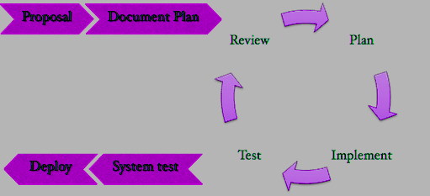

**Figure1: Iterative Software development Model**

**Iterative model**

Iterative model is a development methodology. It as a way to deliver projects without having to spend time on analysis or planning. It evolved from waterfall model. The primary characteristics of Iterative are focusing on small pieces. We have to separate the project into a small task.

**Proposal phase**

For this phase is about creating a proposal for the iWish project. The proposal contains about project introduction, technologies and tool involved, quality standard and project plan.

**Document plan phase**

In this phase is a document of planning and designing the project from the user requirement and system requirement. The document is including Project Management Plan, Software Requirement Specification and Software Design Document.

**Iterative all features**

This phase is about separate the whole system into small features. Then iterative the first feature until last feature. For this phase, it divided into 4 phases.

* **Plan:** Planning the method for creating and test each feature.
* **Implement:** Implement and coding each feature.
* **Test:** Test and debug each feature.
* **Review:** Review and maintain each feature to meet the feature plan.

**System test phase**

For this phase is about testing each feature in this progress. Then integrate all the features into one system and test the whole system following test plan.

**Deploy phase**

In this phase is deploying the system into a real environment. The iWish project has to deploy a web application on a server. For an Android application have to generate to Android application .apk.

### 3.2.2 Status Reporting

|  |  |  |  |
| --- | --- | --- | --- |
| **No.** | **Progress Report** | **Software items** | **Date M/D/Y** |
| 1 | Progress I | - Project Management Plan  - Software Requirement Specification  - Software Design Document  - Feature 1-4  - Traceability record I  - Test Plan  - Test Record | 08/01/2015 |
| 2 | Progress II | - Feature  - Traceability record II  - Test Plan 5-6  - Test Record | 09/22/2015 |
| 3 | Progress ShowPro | - ShowPro  - Poster  - Video Promote  - Video Demo | 11/11/2015 |
| 4 | Final progress | - Traceability record  - Final document  - Final system | 12/25/2015 |

## 3.3 Change Management

Change control procedure

1. Admit the change.
2. Analyze the reason for the change.
3. Send change form to project advisor.
   1. If accept: make a change in the project from change request form.
   2. If reject: Continue in the project and find the way to solve a problem.

4. Analyze the result from changing and modify the document or system to match with change.

**4. Quality Planning [V&V]**

## 4.1Reviews/Responsibility

|  |  |  |  |  |
| --- | --- | --- | --- | --- |
| **Stage Exit Review** | | | |  |
| **No.** | **Stage** | **Review Item** | **Responsibility** | **Reviewer** |
| 1 | Requirements gathering and analysis | Project Proposal | VC,SK | VC,SK |
| 2 | Requirements gathering and analysis | Management Plan | SK | VC,SK |
| 3 | Requirements gathering and analysis | Software Requirement Specifications | VC,SK | VC,SK |
| 4 | Requirements gathering and analysis | Traceability Record | SK | VC,SK |
| 5 | System Design | Software Design Document | SK | VC,SK |
| 6 | Implementation | Code | VC | VC,SK |
| 7 | Testing | Test Plan | VC,SK | VC,SK |
| 8 | Testing | Test Record | VC,SK | VC,SK |

## 4.2Testing

|  |  |  |
| --- | --- | --- |
| **Test Process** | | |
| **No.** | **Test** | **Responsibility** |
| 1 | Unit Testing | VC,SK |
| 2 | Integration Testing | VC,SK |

## 4.3 Software Development Standard

**ISO29110 for Very Small Entity (VSE)**

ISO 29110 is a guide applies to Very Small Entities (VSEs), enterprise, organization, department or project up to 25 people, dedicated to software development. The Guide provides Project Management and Software Implementation process which integrate practices based on the selection of ISO/IEC12207- Systems and Software Engineering –Software Life Cycle process – guidelines for the content of software life cycle process information products (documentation) standards elements.

**Project Management (PM) process**

**PM purpose**

The purpose of the Project Management process is implementing software in a systematic. It will make the project’s objectives in the expected quality, time and costs.

**PM objectives**

**PM.O1**. The *Project Plan* for the execution of the project is developed according to the *Statement of Work* and validated with the Customer. The tasks and resources necessary to complete the work are sized and estimated

**PM.O2**. Progress of the project is monitored against the *Project Plan* and recorded in the *Progress Status Record.* Corrections to remediate problems and deviations from the plan are taken when projecttargets are not achieved. . Appropriate treatment is taken to correct or avoid the impact of risk.Closure of the project is performed to get the Customer acceptance documented in the *Acceptance Record*.

**PM.O3**. The *Change Requests* are addressed through their reception and analysis. Changes to software requirements are evaluated for cost, schedule and technical impact.

**PM.O4.** Review meetings with the Work Team and the Customer are held. Agreements are registered and tracked.

**PM.O5**. *Risks* are identified as they develop and during the conduct of the project.

**PM.O6.** A software *Version Control Strategy* is developed. Items of *Software Configuration* are identified, defined and baselined. Modifications and releases of the items are controlled and made available to the Customer and Work Team including the storage, handling and delivery of the items.

**PM.O7.** Software Quality Assurance is performed to provide assurance that work products and processes comply with the *Project Plan* and *Requirements Specification*.

**PM Activities**

The Project Management Process has the following activities:

- PM.1 Project Planning

- PM.2 Project Plan Execution

- PM.3 Project Assessment and Control

- PM.4 Project Closure

**Software Implementation (SI) process**

**SI purpose**

The purpose of the Software Implementation process is for the analysis, design, construction, integration and tests in the systematically and according to the specified requirements.

**SI objectives**

SI.O1. Tasks of the activities are performed through the accomplishment of the current *Project Plan*.

SI.O2. Software requirements are defined, analyzed for correctness and testability, approved by the Customer, baselined and communicated.

SI.O3. Software architectural and detailed design is developed and baselined. It describes the software items and internal and external interfaces of them. Consistency and traceability to software requirements are established.

SI.O4. Software components defined by the design are produced. Unit test are defined and performed to verify the consistency with requirements and the design. Traceability to the requirements and design are established.

SI.O5. *Software* is produced performing integration of software components and verified using *Test Cases and Test Procedures*. Results are recorded at the *Test Report*. Defects are corrected andconsistency and traceability to *Software Design* are established.

SI.O6. A *Software Configuration*, that meets the *Requirements Specification* as agreed to with the Customer, which includes user, operation and maintenance documentations is integrated, baselined and stored at the *Project Repository*. Needs for changes to the *Software Configuration* are detected and related *Change Requests* are initiated.

SI.O7. Verification and Validation tasks of all required work products are performed using the defined criteria to achieve consistency among output and input products in each activity. Defects are identified, and corrected; records are stored in the *Verification/Validation Results*.

**SI activities**

The Software Implementation Process has the following activities:

- SI.1 Software Implementation Initiation

- SI.2 Software Requirements Analysis

- SI.3 Software Architectural and Detailed Design

- SI.4 Software Construction

- SI.5 Software Integration and Tests

- SI.6 Product Delivery

# 5. Estimated Duration of Tasks

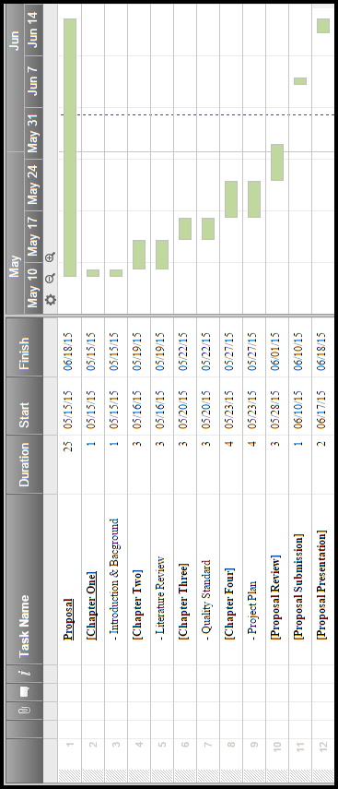

**Figure 2: Proposal Progress**

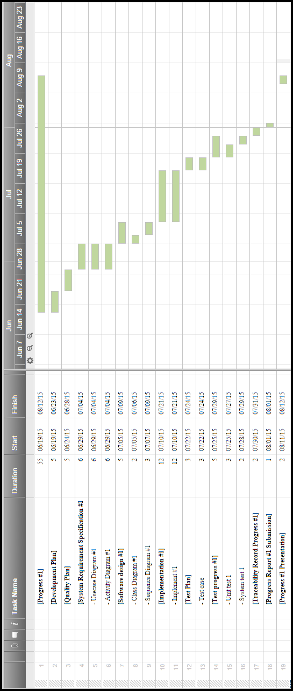

**Figure 3: Progress I**

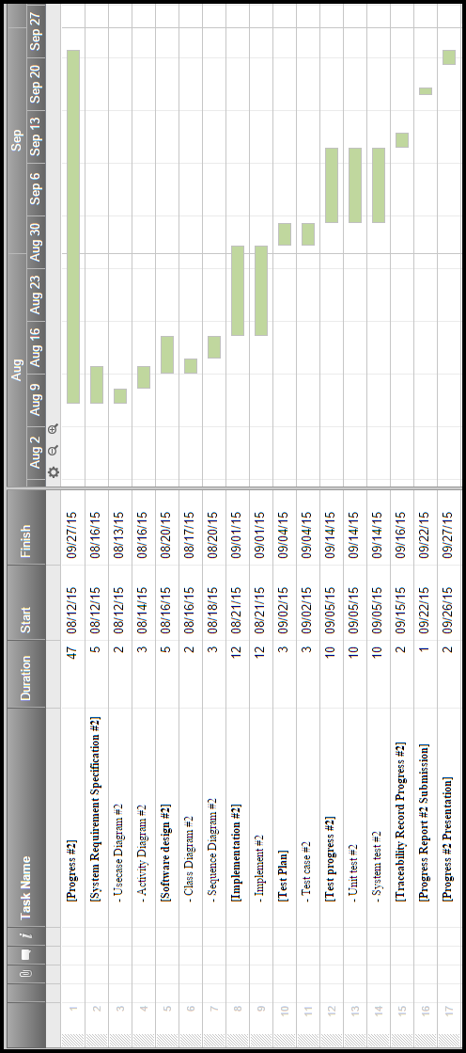

**Figure 4: Progress II**

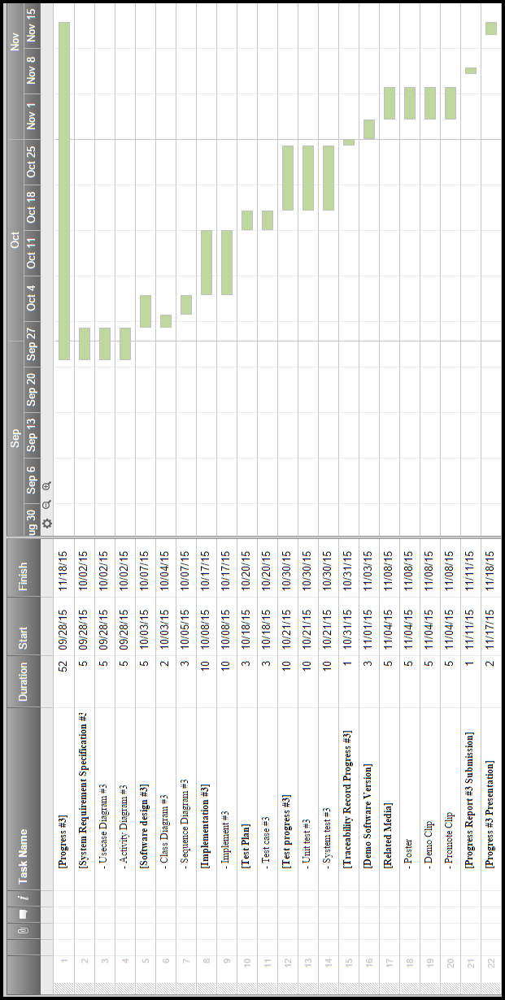

**Figure 5: Progress III**

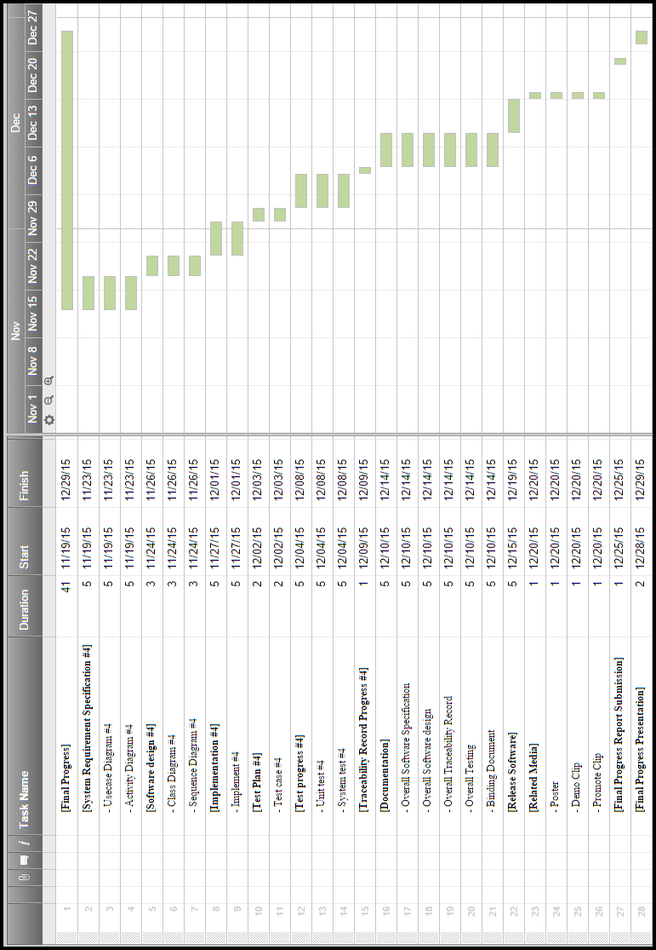

**Figure 6: Final Progress**

# **6. Estimated Effort and Cost**

The cost of this project almost is the printing out the document report. There is some cost for buying NFC tag from eBay. The cost of NFC tag is about $1-5.

# **7. Version Control Strategy**

## 7.1 Naming Conversion

For the filename format that using for all project documents are

iWish - [File name]_[Version].[File format]

## 7.2 Project Repository

**Onedrive**

Onedrive is a file hosting provided by Microsoft that allow the users can upload files to cloud storages and later access. The users can set the sharing files to public for anyone can access or private for someone can access.

## 7.3 Configuration Item Table

|  |  |  |  |  |  |  |
| --- | --- | --- | --- | --- | --- | --- |
| **No** | **Item** | **File Name** | **File Type** | **Owner** | **Path** | **Baseline Version** |
| 1 | Project Proposal | iWish –Proposal V.[version].docx | .docx | VC/SK | / iWish /Proposal/ | 0.5 |
| 2 | Project Plan | iWish – PMP V. [version].docx | .docx | VC/SK | / iWish /Project Plan | 1.5 |
| 3 | Software Requirement Specification | iWish –SRS V. [version].docx | .docx | VC/SK | / iWish /SRS | 1.5 |
| 4 | Traceability Record | iWish –Traceability record V. [version].docx | .docx | VC/SK | / iWish /Traceability Record | 1.5 |
| 5 | Software Design Document | iWish –SDD V. [version].docx | .docx | VC/SK | / iWish /Design | 1.5 |
| 6 | Software Code | iWish –Code_V. [version].RAR | .RAR | VC/SK | / iWish /Code | 1.5 |
| 7 | Test Plan | iWish –Unit test V. [version].docx | .docx | VC/SK | / iWish /Testing | 1 |
| 8 | Test Record | iWish -System_test V. [version].docx | .docx | VC/SK | / iWish / Testing | 1 |

## References

[ 1 ] ISO/IEC 29110:2009 – Process Reference Model

[ 2 ] ISO/IEC 15504:2003-2006 - Process Assessment Model

Procedure for Process Assessment.

[ 3 ]  Project Repository Retrieved July 17, 2015, from https://onedrive.live.com/about/en-us/